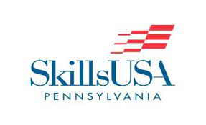

SkillsUSA Pennsylvania to implement Scholastic Esports program

State College, PA, September 20, 2021- Scholastic Esports is a large and growing community and SkillsUSA Pennsylvania is taking the necessary steps to bring Scholastic Esports to schools throughout the Commonwealth. SkillsUSA Pennsylvania has established a new program to their robust offerings promoting Career and Technical Education (CTE) across the state. These events are open to all SkillsUSA PA members.
This program called Pursu.it, was created to encourage student interest in career and technical development in the Computer Science and Information Technology pathways. Also, to engage students in a career path that they may not have considered. Pennsylvania has a shortage of professionals in these industries and this program will assist in nurturing talents and provide opportunities to college scholarships and careers in the Computer Science and Information Technology pathways.
Students will not only have the opportunity to play Scholastic Esports that will offer creative and analytic challenges but also meaningful career and STEM education. Schools across Pennsylvania are invited to join SkillsUSA Pennsylvania to take part in Pursu.it events.
We will be conducting a zoom press conference on Wednesday, September 22, 2021 at 3pm. Please contact Christopher Shirley at the email below to receive a link to the meeting.

Jeri Widdowson
Executive Director SkillsUSA PA
Skillsusapennsylvania@comcast.net
Christopher Shirley
Director at Pursu.it
chris@skilledsos.com

